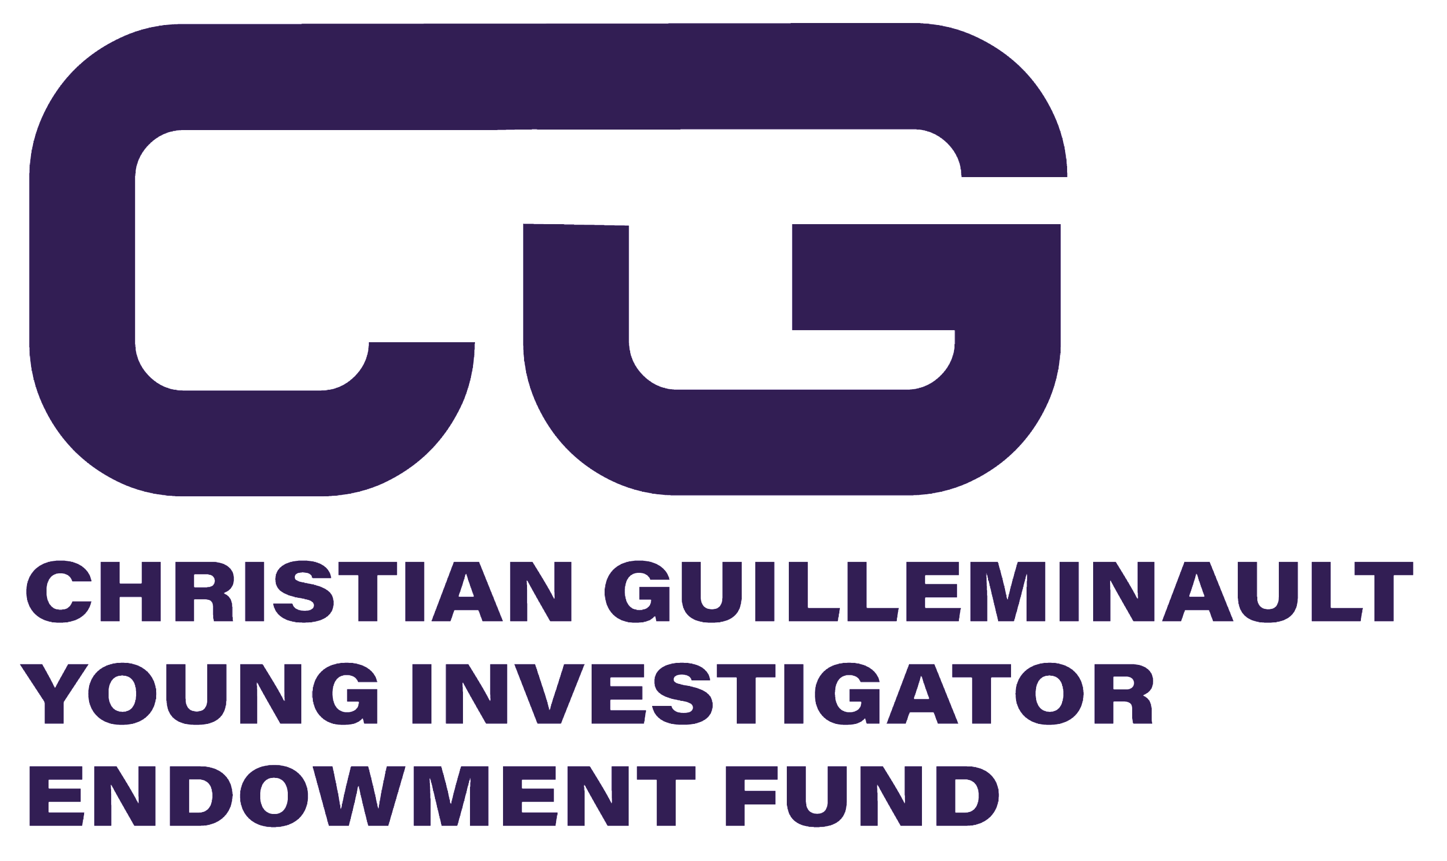

Young or New Investigator Award Application

Present your abstract to our sleep medicine and research audience at IPSA 2021 to be considered for an award from the Christian Guilleminault Young Investigator Endowment Fund. Travel grants of up to $1,000 USD will be awarded to qualifying individuals in honor of this important sleep pioneer. To apply, applicants must meet the following requirements:

Eligibility requirements
- 35-years-old or younger OR be less than 5 years post MD or PhD degree
- Abstract must have already been accepted for oral or poster presentation at IPSA 2021 ONLINE
- Application received by Angie Granum at granum@worldsleepsociety.org by the deadline of January 1, 2021.

Application process:
Email completed application and supporting documents to: Angie Granum at granum@worldsleepsociety.org

Supporting documents (required):
- Official abstract acceptance letter for IPSA 2021
- Copy of accepted abstract

Section 1: Please list your contact information and abstract details.
Full Name:
Age (years):
Home Country:
Date of MD/PhD Completion:
Title of Abstract:

Section 2: Please list the contact details of a mentor or advisor who can verify you meet the requirements.
Advisor/Mentor Name:
Advisor/Mentor Phone:
Advisor/Mentor Email:

Section 3: Please submit your Biosketch and a personal letter stating why you are applying for this award.
Biosketch (max 200 words):
Personal Letter (max 200 words):

Submit application and supporting documents by email to Angie Granum at granum@worldsleepsociety.org by January 1, 2021

